THE DEVELOPMENT OF CREDIT RATING SYSTEM FOR RATE INCREASE FILING WEB-BASED FUNCTIONAL LECTURER

Atiyah Tahta Nisyatina
Majoring of Tehcnic Engineering, Faculty of of Science and Technology
Syarif Hidayatullah the Islamic State University Jakarta
tahtanaariel@gmail.com

ABSTRACT - One of the tasks of the Sub Division is dealing with faculty personnel in positioning the functional lecturer. Obtaining credit figures obtained from the implementation of the three responsibilities of Higher Education is a requirement to apply for promotion lecturer functional. From the results of observation and interview the author, the calculation of credit number that is still manual. This means that there are no acquisition system that can calculate the credit rate calculated in accordance with the rules of credit number. Seeing the problems that occurred, the writer intends to develop a rating system for the submission of credit number of functional web-based promotions. This system is expected to handle data acquisition credit number, the rules of functional faculty promotions, and calculating the appropriate credit rate credit value calculation rule. In developing this system, the authors use the programming language PHP, database MySQL and the V-Model as a method of system development. The development of this system could ultimately minimize the interaction between the lecturer with civil service staff so that issues regarding the calculation of credit value can be avoided; display data and the calculation of credit number, sending a notification (notification) to the faculty and staff employment. For the future, this system is expected to be developed again with the expansion of scope of the system up to university level.

- INTRODUCTION

The human quality needed by the nation of Indonesia in the future is able to face increasing competition with other nations in the world. The quality is generated through the implementation of quality education by professional educators. Law Number 20 Year 2003 on National Education System states that educators are professionals. Therefore, the lecturer as a professional educator has the function, role, and position are very strategic.
In a college-level educational institution or a university, professors become one of the factors supporting progress in the field of education. Lecturer is a person who is given the task by organizing college or university to teach in accordance with educational backgrounds owned. One obligation is to practice what one professor called the three responsibilities of Higher Education is to implement the Education and Teaching, conducting research, implementing Community Services, and Supporting Units. With the elements of the practice of three responsibilities of Higher Education, the lecturers are entitled to a functional position of the government based on theamount of of credit number that lecturers have ( SKMendiknas 36/D/O/2001 number ).
From observations and interviews conducted by the author with several faculty and staff of the Faculty of Shari'ah and Law of personnel, the authors found some problems on the part of staffing the faculty and staff. Problems experienced on the part of professors, among others: the lack of faculty knowledge about how credit value assessment; lecturers do not know the exact amount of credit number that has been owned, so the difficulty for the filing of its functional promotion; no acquisition system which stores the number of credit number that can be seen anytime and anywhere, not knowing when the submission of an increase in functional positions. While the problems faced by the staff of the civil service, among others: there is no integrated system of data storage due to the acquisition of credit number is still using MS-Excel; staff of the staffing difficulties in knowing the number of faculty who are or will propose an increase in functional positions of lecturers; than making note of the proposal due to having to wait gathering reliable data in the form of physical evidence file, and the amount of credit number of the proposed acquisition.
On the basis of the above problems, the author tries to make the development of the credit value assessment system in accordance with the provisions of the percentage calculation of credit value of each element of the three responsibilities of college faculty staffing for the staff and faculty can easily calculate and obtain information about the assessment of credit number for filing increase in functional position.

- STUDY OF A KIND

A study conducted by [3], researching about the Design of Application Appraisal Credit Score (PAK) Web-Based Lecturer (Case Study: Faculty of of Science and Technology UIN Jakarta). This study uses SDLC Waterfall model system development, PHP programming language and MySQL database. This study focuses on the assessment of credit number (PAK) lecturers, regardless of the value of the presentation of each element Tridharma college.
[4] conducted research on "Application Pre Calculating Credit Score Functional Web-Based Lecture. " This application uses the programming language PHP 5 with MySQL database. The development system used is SDLC with a linear sequential model. Pre counting the number of credit applications functional lecturers, assist and provide facilities for lecturers in calculating Credit Score.
From the literature that have been studied, most researchers focus on the calculation of credit value irrespective of the presentation of each element Tridharma college activities. This is what makes the writer is interested to develop the assessment system is web-based credit number, to facilitate the kepegawaianj faculty staff and lecturers to obtain information about credit value assessment in accordance with the percentage of each element Tridharma activity.

- RESEARCH METHODOLOGY

- Data Collection Methodology

The methods I use in data collection among others, to study literature through books and websites. Besides, the author also conducted observations and interviews to conduct analysis to determine the design of new systems to be built in order to stay in sync with business processes that are running. Observations and interviews was conducted from July to December 2010.

- Systems Development Method

Method of system development that writer used in this research is V Model. Broadly speaking, the design of this study can be seen in Figure 1.
Penentuan tema penelitian
Pengumpulan data :
Studi Pustaka
Studi Lapangan
Studi Literatur
Merumuskan masalah dan ruang lingkup
Penentuan konsep dan hipotesis penelitian
Pengembangan sistem menggunakan V Model
Penulisan laporan akhir
Figure 1. Chronology of Development Credit Score Rating System To Increase Submission Web-Based Functional Lecturer.

- DISCUSSION

- Requirement modelling

- Determination of Scope and System Development.
System development is about the percentage of credit number of elements in pemgajuan Tridharma college professors increased functional position. The calculation of credit value in the development of this system following the operational manual credit value assessment of functional promotion to associate professor of lecturers and professors. The development of this system has 3 levels of administrative user is admin, admin staffing faculty, and lecturers.
- Analysis of Current System
The application process increases functional lecturer currently done manually. Lecturer count themselves all credit figures gathered from the elements Tridharma college. Lecturers who proposed acquisition of credit number in the filing of an increase in functional positions are required to collect the physical form of a file / file acquisition credit number and must calculate the cost of credit number that will be filed. The calculation result is converted into a form of waiver form Tridharma college activities. Once completed, the form must be signed by the head of Prodi and submit it to the faculty staff personnel to be re-examined the completeness of the file. Once complete, the staff of faculty staffing proposal would create a form memorandum signed by the dean and then sent to the rector for further processing. The following flowchart of the system running:
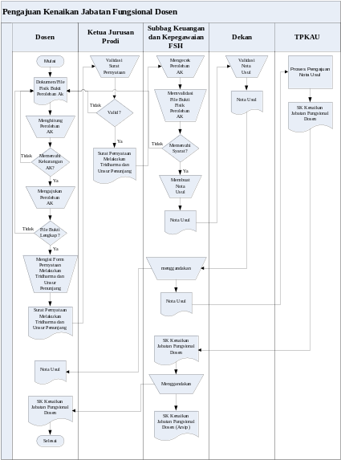
Figure 2. Flowchart system running

- Credit Score Calculation Manual
Here is the calculation of credit rate filing increases manually functional position of assistant professor Expert (150) to the Lektor (200). For the filing of the faculty promotion requires a 50 digit credit. Often there are professors who enter the items of each element of the implementation of activities Tridharma college. Number of items of input errors Tridharma college activities and the acquisition of credit number, it can be concluded that the current system requires a development system that can replace the manual calculation of credit number.

- Analysis of Input (Input)
- Statement of Activities Form three responsibilities of Higher Education and Supporting Units.
- This form has been owned by each lecturer, and filled in accordance with the physical evidence of acquisition of credit number. Form is then signed by the Chairman of the Department Prodi.
- Proposed Memorandum Form.
- This proposal memorandum Form filled by employees with Civil Service Sub signed by the Dean.
- Form List of Proposed Stipulation Credit Score.
- This form contains a list of history professor who proposed the increase in functional positions and the details of the proposed acquisition of credit number.

- Output Analysis
- SK Increase Functional
- Decree (SK) Increase Functional issued by the UIN Syarif Hidayatullah Jakarta and has been signed by the Head of Public Administration and Civil Service Bureau.
- Campaign Map Functional Lecturer.
- Map this campaign is about TMT (Date of Last Entry) and details of the latest acquisition of credit number, along with details of the shortage of credit number is required to file a further increase in functional position

- Identify needs
- On systems running, lecturers find it difficult to know when filing subsequent increase in functional position.
- Lecturers do not know the exact number of credits review which lecturers have been collected, and lack of credit number is required to propose an increase in functional positions.
- Because it is still manual, lecturers and employees of Sub Division Officer found it difficult to access data and information required in terms of credit rate calculation and filing of an increase in functional positions lecturer.
- Civil Sub Division Officer had difficulty in making the report waiting list rank faculty, filing reports increase in functional positions professors, and socialize SOP regarding the calculation of credit number.

- Requirements Analysis (Requirements)
- Functional Requirements
- Data storage management personnel consisting of personal data of each faculty, review the data acquisition credit number lecturer, data review lecturers lack of credit number for filing subsequent increase in functional position. User management settings. Making a feature that allows end users. Preparation of the Memorandum of proposal submission print features functional teacher promotions. Making feature calculation procedures and requirements of credit number in the filing of an increase in functional positions lecturer.
- nonfunctional Requirements
- Performance, Information, economics, control, eficiency.

- Analysis of the Proposed System
A lecturer who will propose the acquisition of credit in the process of filing rate increase in functional position must first have the physical evidence file acquisition credit number, after which the faculty can directly input the proposed acquisition of credit number on the credit value assessment system. When the lecturer in question has never been proposed acquisition of credit number, then the system will automatically give an option (option) to the lecturer to be able to choose the type of increase in functional positions that will be filed, regular or long jump title. Each option type functional promotion is based on the requirements and procedures. If the lecturer in question has previously choose the type of increase and the proposed acquisition of credit number, then after login the system will directly display the review of the acquisition of credit number and percentage calculation of credit number. After the acquisition of credit number has met the requirements for the filing of an increase in functional positions, the lecturer can click the finish button. Furthermore, lecturers provide physical evidence of acquisition rate and its loans to Sub Officer Statement Tridharma had engaged in college and supporting element which was signed by the Chairman of the Department Prodi. Furthermore, employees Sub Officer can validate the proposed acquisition of credit rates in accordance with the existing physical evidence. Then fill in the form of Civil Service employees Subbag Memorandum proposal that has been available automatically in the system for subsequent printed and submitted to the Dean for signature. After the proposal Memorandum issued, the employee Sub Officer Faculty of of Sharia and Law will send it to PART Administrative Officer UIN Jakarta. Copies of the Memorandum proposal was submitted to the lecturer concerned and as an archive. The following flowchart of the proposed system:
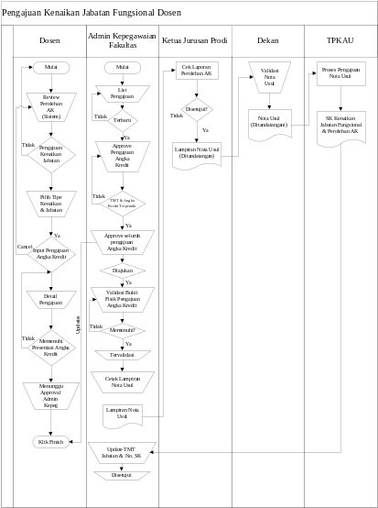
Figure 3. Flowchart for proposed

- Credit value assessment system
Assessment of credit figures in the development of the proposed share acquisition system every implementation element Tridharma college activities and supporting elements into a presentation according to the value stated in the SOP assessment credit digits.
Table 1. Percent Value of Higher Education Tridharma Elements
No | Pengajuan Kenaikan Jabatan Fungsional Dosen | Dikjar (30%) | Penelitian (25%) | Pengabdian (15%) | Penunjang (20%) | Saving | Kurang KUM
No | Pengajuan Kenaikan Jabatan Fungsional Dosen | MIN | MIN | MAX | MAX | Saving | Kurang KUM
1 | Tenaga Pengajar (0) – Asisten Ahli (150) | 0 | 0 | 0 | 0 | Tidak | 150
2 | Asisten Ahli (150) – Lektor (200) | 15 | 12.5 | 7.5 | 10 | Tidak | 50
3 | Lektor (200) – Lektor (300) | 30 | 25 | 15 | 20 | Tidak | 100
4 | Lektor (300) – Lektor Kepala (400) | 30 | 25 | 15 | 20 | Tidak | 100
5 | Lektor Kepala (400) – Lektor Kepala (550) | 45 | 37.5 | 22.5 | 30 | Ya | 150
6 | Lektor Kepala (550) – Lektor Kepala (700) | 45 | 37.5 | 22.5 | 30 | Ya | 150
7 | Lektor Kepala (700) – Guru Besar (850) | 45 | 37.5 | 22.5 | 30 | Ya | 150
8 | Guru Besar (850) – Guru Besar (1050) | 60 | 50 | 30 | 40 | Ya | 200

- Feasibility study
- Legality
In developing this system, the authors have received approval and full support from the Assistant Dean II, who has obtained consent Dean of Faculty of Shari'ah and Law. In this case, II directly supervises the Assistant Dean of Finance and Personnel Sub Faculty of Shari'ah and Law. Legality of this system has been demonstrated directly reinforced by the dean and lecturer in Faculty of Shariah and Law faculty meeting held on the day fixed Thursday, September 2, 2010, which took place in the Space Theatre lt. 2 Faculty of Shari'ah and Law is starting at 09:00 to 12:30 pm.
- Technical feasibility
Feasibility from a technical standpoint, the performance of the system that the author has developed its stability can be proved by being able to handle more data, this can be seen in the attachment field testing. Authors developed a system that is web based, allowing users to be able to access these systems with various types of web browsers. This application was developed using the PHP programming language that is multi platform so that not only can run on any windows based operating system, but can also run on Macintosh operating system, Linux.
- Feasibility Time
Because this system is designed to be able to calculate the credit rate in computerized acquisition in accordance with the requirements and procedures, then the presence of this system can save time faculty and employees of Sub Officer. This system is also built with web-based, making it possible for faculty and staff to Sub Officer can access data whenever and wherever.

- Architectural Design

- System Design
- Design Context Diagram
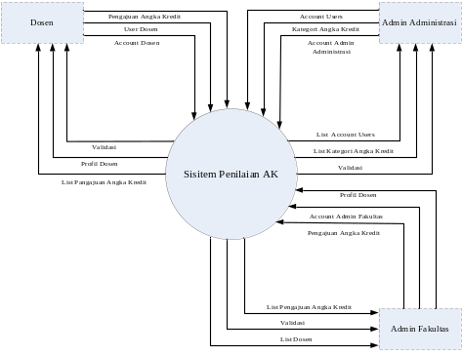
Figure 4. Context Diagram

- Design Diagram Zero
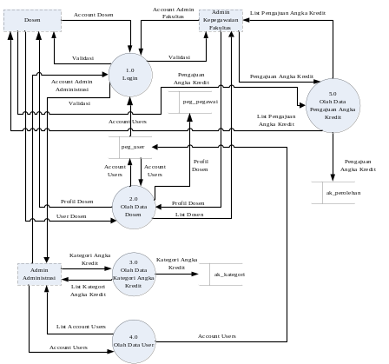
Figure 5. Zero Diagram

- Detailed Design Diagram
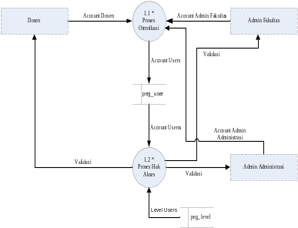
Figure 6. Detailed Diagram

- Design database
- Normalization
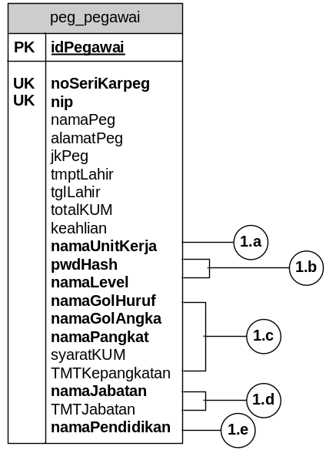
Figure 7. Normalization

- ERD Design
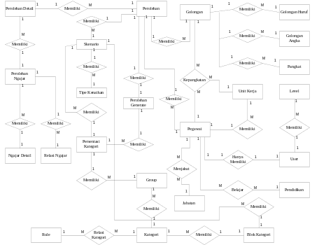
Figure 8. ERD

- Conversion of ERD to the LRS
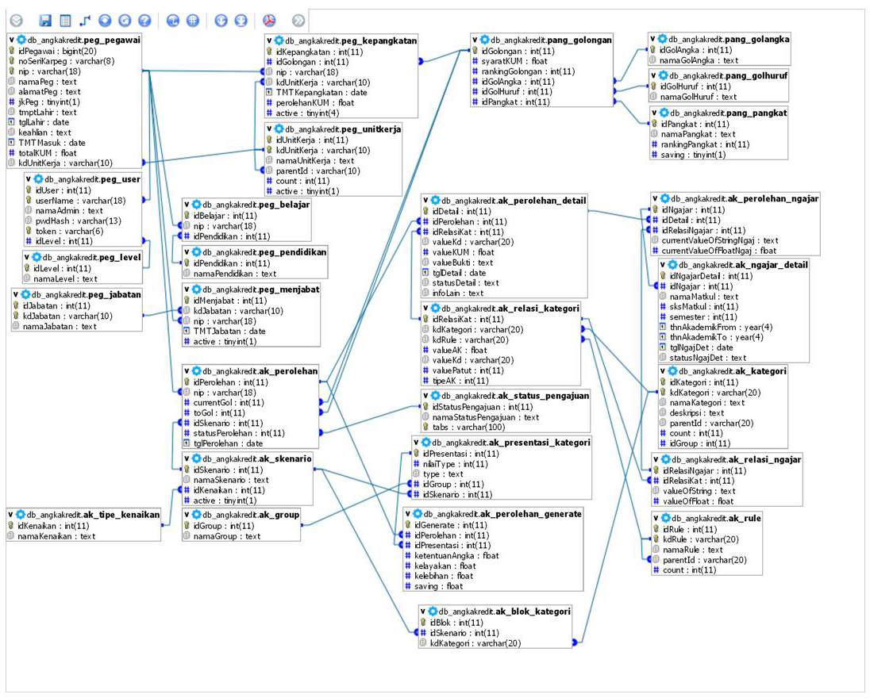
Figure 9. The LRS Conversion ERD

- Database Table
No. | Field | Type | Extra
1. | idBlok | int (11) | Primary key, auto_increment
2. | idSkenario | int (11)
3. | kdKategori | varchar(20)
Figure 10. Database Table

- Interface Design Applications
- Application Structure
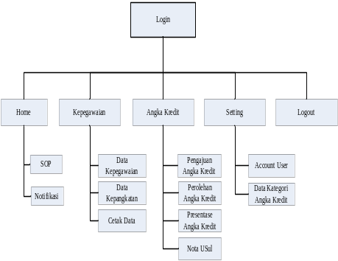
Figure 11. Application Structure

- Page Login
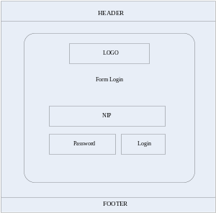
Figure 12. Login page

- Main Page
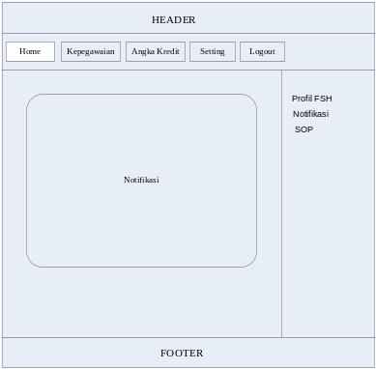
Figure 13. Main Page

- Page Personnel
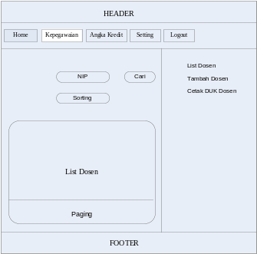
Figure 14. Personnel Changes

- Changes Credit Score
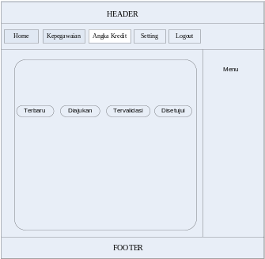
Figure 15. Changes Credit Score

- Page Settings
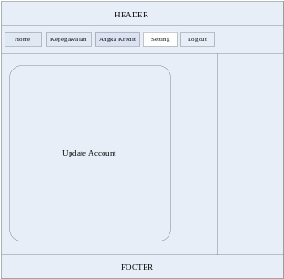
Figure 16. Page Settings
- Component Design

- Design modules
In this stage, the authors make the division of the system components into modules complete with a smaller provision CRUD matrix for each module.
Tabel 2. CRUD
No | Komponen | Modul | User
No | Komponen | Modul | Admin Administrasi | Admin Kepegawaian Fakultas | Dosen
1. | Home | Notifikasi | R | R | R
1. | Home | SOP | R | R | R
2. | Kepegawaian | Data Kepegawaian | X | CRUD | R
2. | Kepegawaian | Histori Kepangkatan | X | R | R
2. | Kepegawaian | Cetak Kepegawaian | R | R | R
3. | Angka Kredit | Pengajuan Angka Kredit | X | CRUD | CRUD
3. | Angka Kredit | Perolehan Angka Kredit | X | R | R
3. | Angka Kredit | Presentase Angka Kredit | X | R | R
3. | Angka Kredit | Cetak Nota Usul | X | R | R
4. | Setting | Account User | CRUD | RU | RU
4. | Setting | Data Kategori Angka Kredit | CRUD | X | X
4. | Setting | Data Rule Kategori Angka Kredit | CRUD | X | X

- Design Interface Module
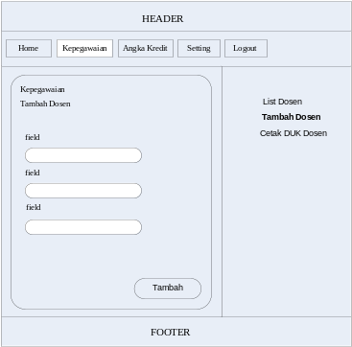
Figure 17. Design Interface Module

- Design of state transition diagrams (STD)
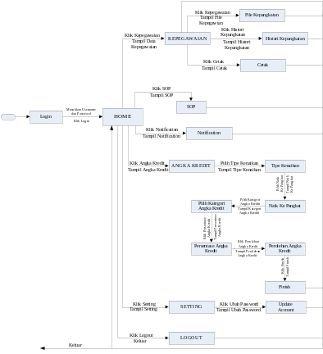
Figure 18. STD lecturer

- Code Ggeneration
Code generation phase is the phase coding of all the authors conducted a design that has been done before, better application design, database design, and interface design. Coding to the design of these applications, the authors use the programming language PHP 5. As for the design of the database I use MySQL version 5.0.21 as data storage, and phpMyAdmin version 2.8.1 as an interface.

- Executable software

- Spesifikasi hardware
Tabel 3. Spesifikasi Hardware
No | Hardware | Server | Client
1. | Processor | Dual-Core 2.20 GHz | Pentium 4
2. | Memory | 2 GB | 512 MB
3. | Monitor | Resolusi display 1280 x 800 (Recomended) | Resolusi display 1280 x 800 (Recomended)
4. | Modem/Koneksi Internet | Ya | Ya
5. | Ethernet Card | Ya | Ya
6. | Printer (Local/Network Printer) | Ya | Ya
7. | DVD/CD ROOM | Ya | Tidak
8. | Keyboard | Ya | Ya
9. | Mouse | Ya | Ya

- Spesifikasi software
Tabel 4. Spesifikasi Software
No | Software | Server | Client
1. | Bahasa Pemrograman | PHP versi 5
2. | DBMS | MySQL
3. | OS | Windows XP | Windows, Linux, dll
4. | Browser | Mozilla Firefox 3.6 | Mozilla Firefox 3.6
5. | Acrobat Reader | Adobe Reader versi 5.0 atau lebih atau pdf reader lain | Adobe reader versi 5.0 atau lebih atau pdf reader lain

- Unit testing
In the coding of this application development, the authors tested the source code available on each module. It aims to find out where the mistake or error that caused incorrect writing of source code or programming errors.
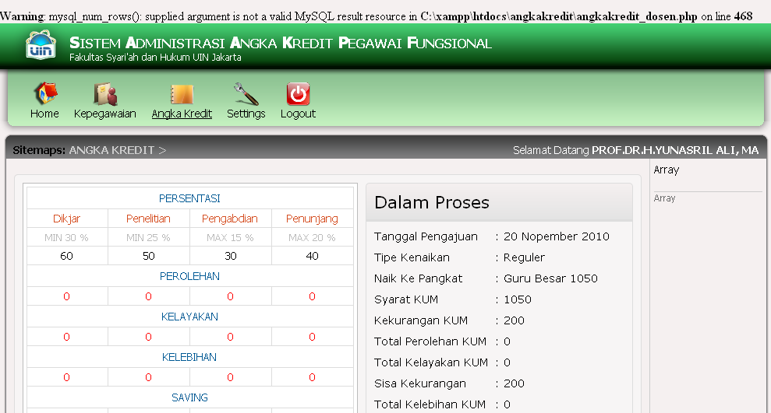
Figure 21. Code error
- Integration testing
Integration testing is the stage where the authors conducted a series of tests on each module interfaces specified in the previous stage. The expected outcome of this stage is done so that no error of integration between the interface with the links in the application

- System testing
The next stage in the development system is the system testing v model, which is doing the testing phase of the whole system to determine whether or not the integration of each module in the system. This phase is expected to provide a clear picture of harmony among all user interactions performed by the system, such as the input process, edit, update, and delete by entering sample data.

- Acceptance testing (Pengujian Penerimaan)
System acceptance testing is done by trying out the system development is a direct result of user II consisting of deans, faculty personnel staff, and faculty by distributing questionnaires. The number of respondents who fill out a questionnaire form numbered 12 people. System acceptance test results as a whole can be seen in the following table:
Tabel 5. Hasil Pengujian Penerimaan Sistem
No. | Topik Pengujian | Persentase (%) | Penilaian
1. | Aplikasi yang user friendly | 75 | Baik
2. | Aplikasi dalam menghitung angka kredit | 83 % | Sangat Baik
3. | Aplikasi sesuai dengan kebutuhan user | 83 % | Sangat Baik
4. | Aplikasi secara keseluruhan | 75 % | Baik
5. | Kelengkapan informasi tentang angka kredit | 75 % | Baik
6. | Aplikasi dalam memperoleh dan memelihara informasi perolehan angka kredit | 66 % | Baik
7. | Pengembangan Sistem | 91 % | Sangat Baik

- CONCLUSION

In this research, there are some things you can conclude the authors, namely:
- The system developed allows the teacher to file simultaneous acquisition of credit number, this can indirectly minimize the interaction between the lecturer with civil service staff so that the conflicts and problems regarding the credit rates caused by the decreasing volume of civil service staff work can be avoided.
- Based on the problems that a lack of knowledge about the number of lecturers who have been lecturers earn credit, then this system can display the number of credits owned, needed, and faculty gathered for the purpose of filing the increase in functional positions.
- Based on the problems that the lack of information obtained by the faculty and staff employment difficulties in providing information regarding when the time should professors propose an increase in functional positions, then the system can send notification (notification) to the faculty and staff personnel regarding the promotion of functional time next lecturer based TMT (Last Login Date).
- The system can display information about the data themselves from their lecturers, and displays information about the SOP of each level of increase in functional positions that may be proposed by the lecturer. This indirectly allows staff personnel in socializing the SOP calculation of credit value in the process of obtaining an increase in functional position lecturer.
- The system developed allows staff personnel in calculating the number of credit proposed acquisition by the lecturer, and find out how many professors who do not, currently, or have put forward an increase in functional positions. This system allows staff and personnel in creating or printing the memorandum attached proposal.
- Based on the problems of lack of access to obtain information about the calculation of credit number, so this system was developed based on web. Where possible, faculty and staff personnel to access and obtain information regarding the calculation of credit value in the process of filing an increase in functional positions.

REFERENCES

[1] Jalal, Fasli, 2009, Pedoman Operasional Penilaian Angka Kredit Kenaikan Jabatan Fungsional Dosen ke Lektor Kepala dan Guru Besar, Nomor 4565/DI.3/C/2009 –kata pengantar-, Jakarta
[2] Fathansyah, Ir. (1999). Basis Data. Bandung: Informatika.
[3] Hardi, Tomi, 2010, Rancang Bangun Aplikasi Penilai Angka Kredit (PAK) Dosen Berbasis Web Studi Kasus Fakultas Sains dan Teknologi UIN Jakarta, Skripsi Tidak Diterbitkan.
[4] Prasetoy, Budhi Dedi, 2010, Aplikasi Pra Penghitungan Angka Kredit Jabatan Fungsional Dosen Berbasis Web.
[5] Pressman, Roger, 2010, Software Engineering: A practitioner’s Approach, Seventh Edition International Edition, Singapore, McGraw-Hill.
[6] Kendall, Kenneth E, dan Kendall, Julie E, 2003, Analisis dan Perancangan Sistem, Jakarta, Pearson Education Asia Pte. Ltd dan PT. Prenhallindo

[7] http://fsh-uinjkt.net/
Diakses: [25 Oktober 2010, 12.45 PM WIB]

[8] http://pusatbahasa.diknas.go.id/kbbi

Diakses: [01 Oktober 2010, 16.10 WIB]

